Date: 15/05/2023

**Explore the Storage services of Azure.**

-The most of the services are same as AWS, so first I have seen the details of Storage services provided by Azure.

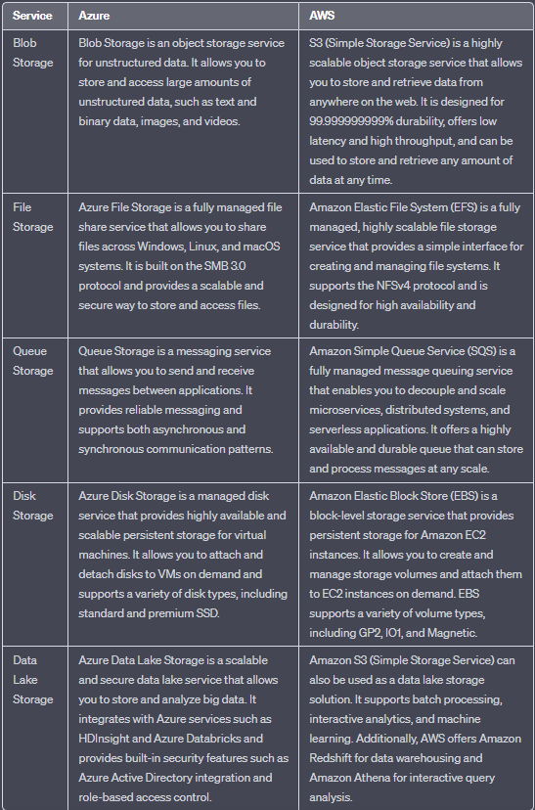

**Azure Blob Storage:** Blob Storage is designed for storing and serving large amounts of unstructured data, such as text, images, videos, and binary files. It provides high scalability, durability, and availability for your data. Blob Storage offers three types of blobs: block blobs for storing files, append blobs for appending data, and page blobs for random access.

**Azure Files:** Azure Files offers fully managed file shares in the cloud, providing a platform as a service (PaaS) solution for file storage. It enables you to create file shares that can be accessed using the Server Message Block (SMB) protocol, making it easy to migrate existing file-based applications to Azure.

**Azure Tables**: Azure Tables is a NoSQL key-value store that provides schema less storage for structured data. It is suitable for storing large amounts of structured data that require fast and scalable access. Azure Tables can be a good choice for applications that require simple querying and data storage, such as IoT telemetry, user data, and metadata storage.

**Azure Queues:** Azure Queues provide a simple message queuing system for decoupling components in a distributed system. It enables asynchronous communication between different parts of an application, helping to improve scalability and reliability. Azure Queues are often used for tasks like background job processing, inter-process communication, and buffering requests.

**Azure Disk Storage:** Azure Disk Storage provides durable and high-performance block storage for virtual machines (VMs) in Azure. It offers both managed and unmanaged disk options, allowing you to attach disks to VMs and use them as persistent storage for applications and data.

**Azure Data Lake Storage:** Azure Data Lake Storage is a scalable and secure data lake solution for big data analytics. It can handle large volumes of structured and unstructured data, making it suitable for big data processing frameworks like Apache Hadoop, Apache Spark, and Azure HDInsight.

**Some comparative study in terms of features and use case.**

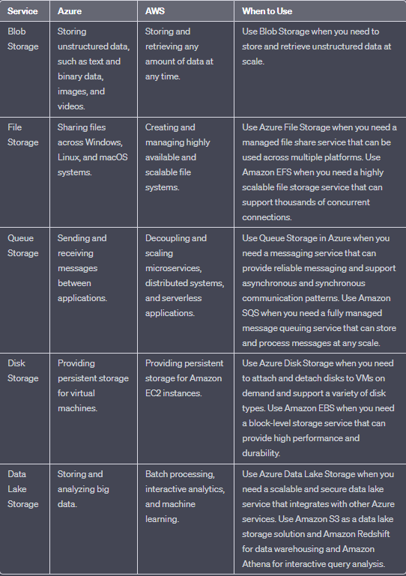

**(Task: Make one single File storage that can be accessed by Linux and Windows VMs.)**